Comparison of PC164C-EX2, RunCam Night Eagle, & other cameras, and “0.5” focal reducers, on the same Hyades star field with an 80mm short-tube “Midi” system
Early in the new year, the RunCam Night Eagle camera I ordered was delivered, and finally on Jan. 5 UT, the sky here cleared up so that I could test that camera and a Supercircuits PC164C-EX2 with two 80mm short-tube “Midi” systems. I recorded short videos with each camera on one of the Midi systems (set up on stationary “drift-through” paver mounts), the other one being just for a real-time comparison (kept with an EX2 and Knight Owl 0.5 focal reducer). Besides the two cameras, I used 4 different “0.5” focal reducers (and also with NO focal reduction) and a Mallincam “0.5” focal reducer; Watec 910HX and Mallincam RECON 828 cameras were also tested, on Jan. 25, and on Feb. 14 (captured with a Star Tech direct to a laptop PC) and Feb. 21. I give Web sites where the different items can be obtained, at the end:
One marked “Knight Owl” obtained at least 5 years ago from Knight Owl in Pennsylvania.
The “2015 0.5 focal reducer”, a similar-looking 0.5 focal reducer bought in 2015 from Hunter Wu (eBay ID hunter20099) in China. In email correspondence, Hunter confirmed that he supplied the 0.5 focal reducers that Knight Owl sold; his company etched “KNIGHT OWL” on the focal reducers before sending them to Knight Owl in Pennsylvania.
In November 2016, I ordered 3 more “2016 0.5 focal reducers” from Hunter, email hunterwzh@hotmail.com.
All of the above also used the 0.5-in. (or 12.7mm) “Alan Smiley” adapter used by Scotty Degenhardt, and a 5mm spacer.
In late January 2017, I ordered a 0.5 focal reducer and adapter from Mallincam.
The star field I imaged was the core of the Hyades, with vertical direction up at about 6h UT Jan. 5:
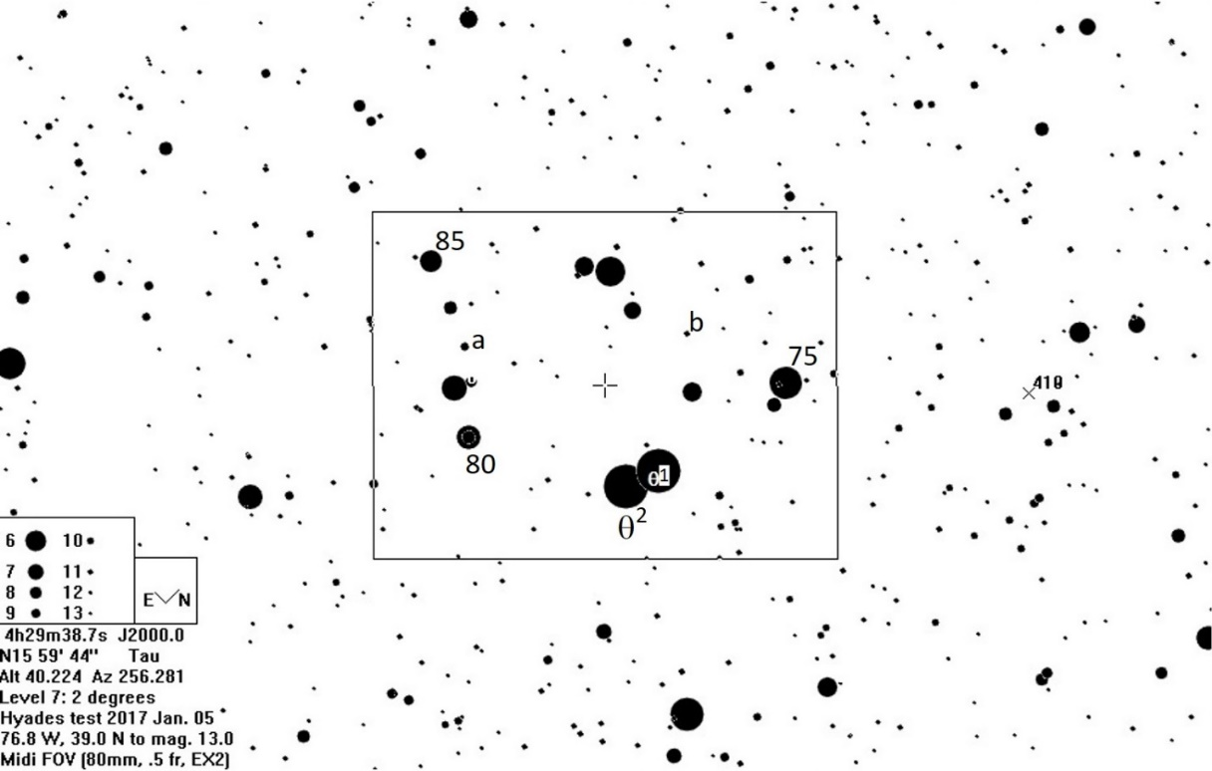
Most of the stars in the field are bright, but there are some relatively faint stars, such as “a”, mag. 9.4, and “b”, mag. 10.7. I haven’t tried to determine limiting magnitudes; Tony has done that well in his comparisons of different cameras on another star field with a larger telescope. This comparison was to test the different focal reducers, as well as the new RunCam Night Eagle, with small very portable telescopes that might be used for remote-station deployments. The rectangle shows the field of view that Scotty Degenhardt recommended for the 80mm “Midi” systems like those used here. The observations were made at our home in Greenbelt, MD, Long. 76.8° W, Lat. 39.0° N.
Observation pictures taken from ZR camcorder video recordings (but direc are provided below. The corresponding video files, each about 20 megabytes (but the ones without focal reduction are larger), can be made available from the IOTA Dropbox folder. Use the .avi files from the Dropbox folder, rather than just these single-frame images (from Virtual Dub), for limiting-mag. or other analysis beyond my assessments. On each of the images, I measured the distance “A” in mm from 85 Tauri (in the upper left of the images with focal reduction) to 75 Tauri (on the right, those images) on the screen of an old 9-inch TV-VCR combo unit, for comparison. The figures below are full frames generated by exporting .jpeg sequences from the video files using Virtual Dub. I’ve resized the figures to fit the space of this Word file, but all of them are full video frames.
Figure 1: This is with no focal reduction, using the PC164C-EX2; an extension tube was needed to achieve focus. In this figure, 75 and 85 Tauri could not be imaged simultaneously, so the distance “B” from 80 Tauri (near bottom) to 85 Tauri (upper left) was measured instead; it was 144mm. This image was actually taken at about 4h UT of Jan. 8, so the altitude was about 60°. The video file is 20170108Hyades6.avi.
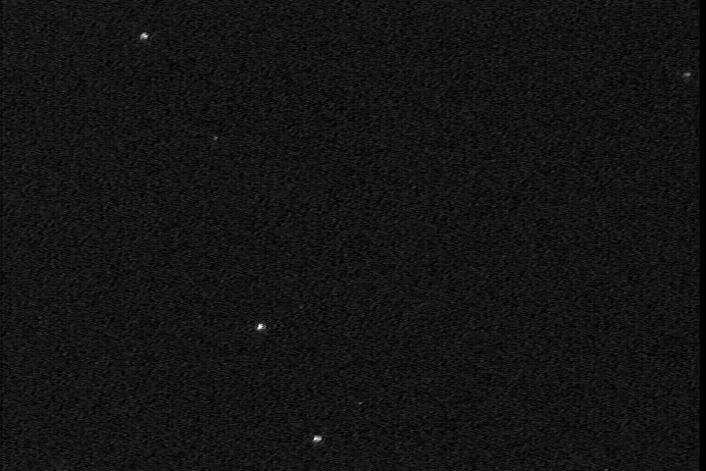
Focal Reduction
Focal reducers are important for recording asteroidal occultations for two reasons: 1 – They give a larger field of view, allowing you to see more stars and more easily navigate to the target star field and 2 – they increase your sensitivity, allowing you to record fainter stars (again, more stars in the FOV), since the seeing disk of each star is concentrated on fewer pixels, increasing the light intensity on each pixel. Our “reference” focal reduction, illustrated on the Hyades with Figure 2 below, is achieved with the “classic” focal reduction system developed by Scotty Degenhardt for the mighty mini. But it can be used effectively on any telescope that takes 1.25” eyepieces. The parts are illustrated well at http://www.asteroidoccultation.com/observations/NA/CameraAttachments.JPG where the parts for it are B, C, and D. “A” is just the PC164C-EX2 camera, but any C-mount camera can be used in its place. For the focal reduction, the critical pieces are B (5 mm spacer), C (the 12.7 mm special “Alan Smiley” spacer, or a shorter “10 mm” one sold by Hunter Wu), and D (the “Knight Owl” focal reducer, now available from Hunter Wu). For lunar occultations, you usually want no focal reduction, to reduce the lunar glare background; in that case, instead of B, C, and D, you just use G, a smooth C-mount to 1.25” adapter.
Figure 2: This is the “reference” focal reduction image, using the Knight Owl focal reducer and PC164C-EX2 camera, the “classic” Midi; distance A was 147mm and B was 68.2mm. Consequently, dividing B here by B from Fig. 1 gives an actual focal reduction of 0.47, a little better than the “advertised” 0.50, probably due to the special 0.5-inch spacer that Scotty found was optimum. Besides the larger field, fainter stars are imaged, since the seeing disks of all stars cover fewer pixels, thus, more light on each pixel. The actual field of view is a little larger than what Scotty specified. As usual with the EX2’s, there are some hot pixels. The video file is 20170105Hyades1.avi:
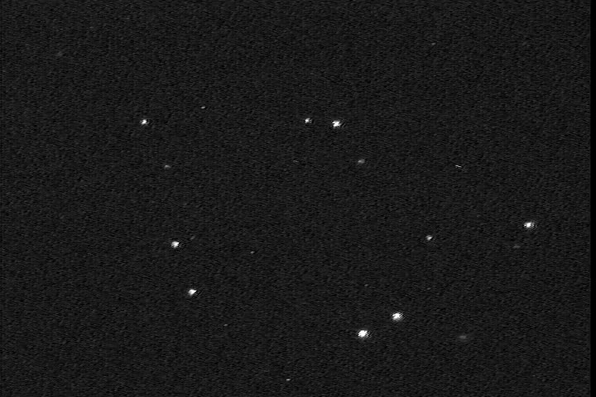
Figure 3: This used the 2015 focal reducer and the PC164C-EX2 camera. The 75 – 85 Tauri distance was 144mm, implying a focal reduction of 0.46, virtually the same as for Fig. 2; the video file is 20170105Hyades2.avi:
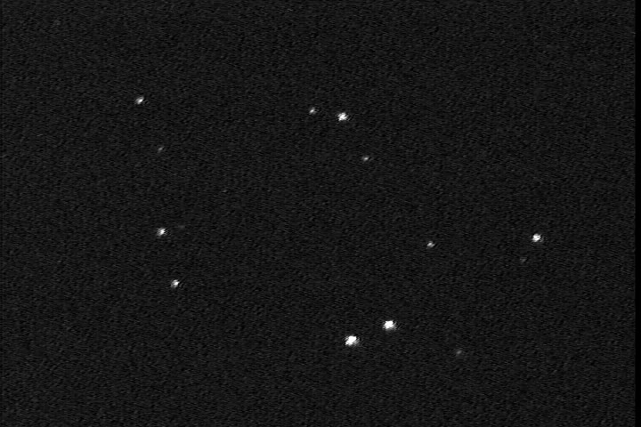
Figure 4: This used a 2016 focal reducer and the PC164C-EX2 camera. The 75 – 85 Tauri distance was 187mm, giving a focal reduction of 0.60, with noticeable coma, & ghost images for bright θ¹ and θ² Tauri; video file 20170105Hyades3.avi:
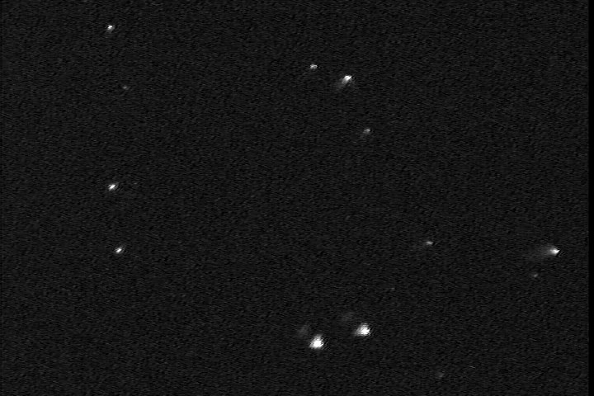
If you obtain a focal reducer from Hunter Wu and the view looks like this, the lens in the focal reducer is reversed. Another way to tell this is to just inspect the focal reducer. The bottom of the letters, ‘1.25” 0.5X Focal Reducer”, are on the end that goes into the telescope eyepiece holder (that is, points to the stars) and that side of the lens should be convex (center sticking out relative to the edges), while the other side of the lens, pointing to the camera, is flat, or nearly so (it may be slightly concave, but not nearly as much as the other side is convex). So if the side of the lens towards the telescope and stars is flat, the focal reducer is reversed. Hunter Wu said that their current batch of these focal reducers were all made with this error; when you place your order, you might ask him about it, to see if the one you buy is alright, or is reversed, but you can tell by the inspection just described. If it is reversed, you can flip the lens yourself. There is a narrow black metal ring that holds the lens in place (on the side towards the telescope, the side at the bottom of the letters etched on the side); it has two small notches. Using a toothpick, icepick, or knife with a sharp point, place the point in one of the notches, and then you can unscrew the ring. Once it is removed, if you turn the focal reducer upside down, the lens will fall out. Just put it back in the other way (that is, “flipped”), and screw the narrow ring back in to secure it. Our tests showed that when this was done, the focal reducer was all right, and produced correct images with focal reduction 0.47, just like the “reference” image shown in Fig. 2.

Figure 5: This is using the RunCam Night Eagle with no focal reduction; an extension tube was needed to achieve focus. In this figure, 75 and 85 Tauri could not be imaged simultaneously, so the distance “B” from 80 Tauri (bottom left) to 85 Tauri (upper left) was measured instead; it was 120mm. Since this camera uses a ½-in. chip rather than a 1/3rd-in. chip that the PC164C-EX2 has, the field of view is proportionally larger. The image was actually taken at about 4h UT of Jan. 8, so the altitude was about 60°. The video file is 20170108Hyades7.avi.
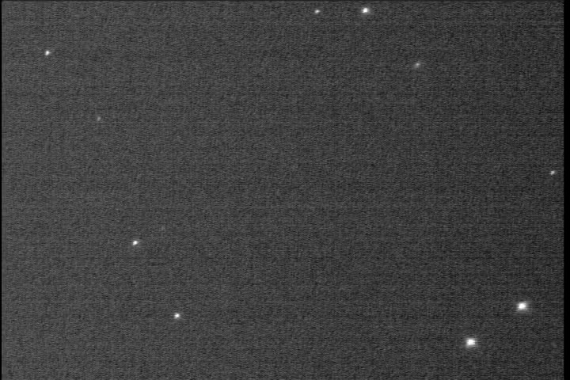

Figure 6: This used the Knight Owl focal reducer and the RunCam Night Eagle camera. The 75 – 85 Tauri “A” distance was 108.7mm and the “B” distance was 49.5mm, so the field of view (FOV) linear size is about 4/3rds times that with the PC164C-EX2, and the focal reduction is 0.41; the video file is 20170105Hyades4.avi:
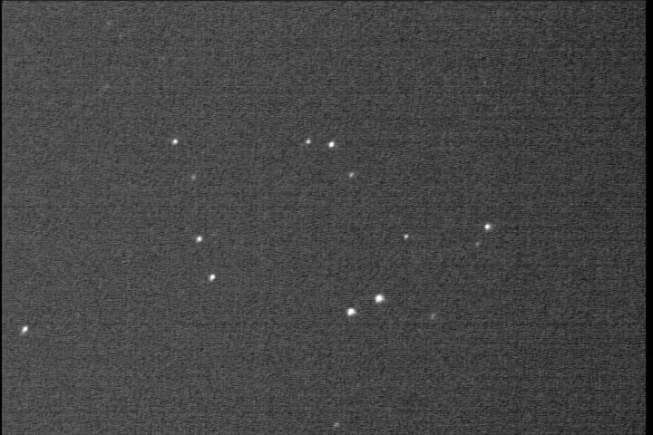
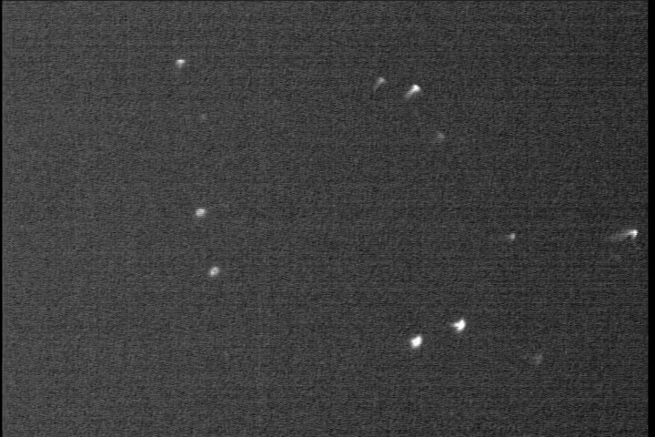
Figure 7: This used a 2016 focal reducer (reversed) and the RunCam Night Eagle camera. The “A” distance was 160mm, giving a focal reduction of 0.61, with again coma; an extension tube was needed to focus; the video file is 20170105Hyades5.avi:

If your field looks like this, you need to flip the lens, as described after Fig. 4.
Figure 8. Mallincam 0.5 focal reducer, 19.5mm adapter, and 5mm spacer ring with the PC164C-EX2 camera. The actual focal reduction is 0.58, so there’s not as much reduction as with the “classic” focal reducer combination.
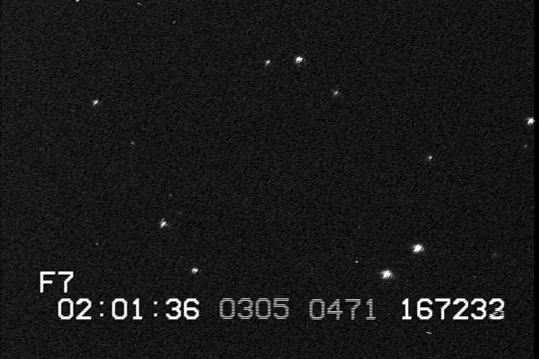
If two 5mm spacer rings are used rather than one, the focal reduction is 0.595, so just one is better. I also tried to use the Mallincam “0.5” focal reducer with the half-inch adapter and 5mm spacer that is used with the Knight Owl (and Hunter Wu) focal reducer, but that would not achieve focus. On Mar. 22, I recorded the Hyades field with the 19.5mm adapter with NO 5mm spacer; that achieved a focal reduction of 0.605, also greater than with 1 5mm spacer, as shown in Fig. 8 above.
Figure 9. This used the Knight Owl focal reducer and a Watec 910HX camera in non-integrating mode, using AGC with gamma 0.45. Like the RunCam Night Eagle, the Watec camera has a half-inch chip and the linear dimensions of the FOV are 1.33 (4/3rds) times those of the PC164C-EX2.
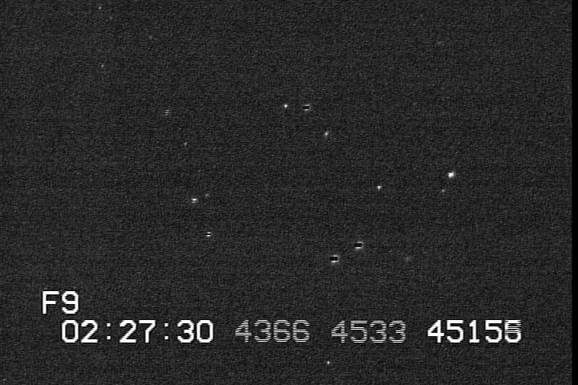
Figure 10. This used the Knight Owl focal reducer and a Mallincam RECON828 camera in non-integrating mode (Sens Up off). Like the RunCam Night Eagle, the Mallincam camera has a half-inch chip and the linear dimensions of the FOV are 1.33 (4/3rds) times those of the PC164C-EX2.
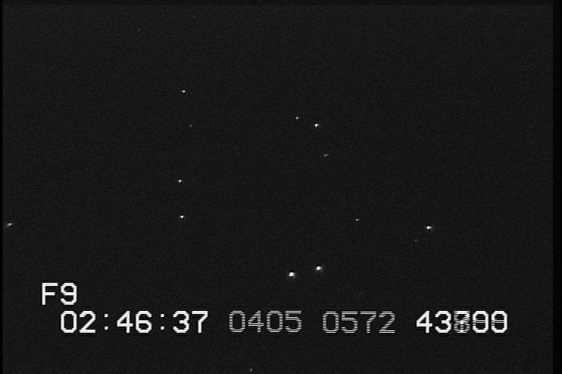
Other recordings were made with the Watec and Mallincam cameras with up to 16 fields integration, but our location is mildly light-polluted so the backgrounds for these are brighter, not giving a good idea of the deeper reach of the cameras in integrating mode. Others have done better tests of that from darker locations. For comparison of the different cameras, especially the Watec and Mallincam cameras, Steve Conard, steve.conard@comcast.net, has done extensive tests at dark sites with larger telescopes to quantify their sensitivities.
Results adding 5mm spacers and using the Hunter Wu adapter
Since the above was written (2017 March 25), I obtained a short “10 mm” adapter from Hunter Wu and decided to test it specifically with the RunCam Night Eagle camera (which has the same housing and chip size as the new RunCam Night Eagle Astro camera) and variable number of 5mm spacers. Clear sky early on 2017 April 3 (early evening April 2 local time) allowed me to make the tests with these, still using the 80mm “midi” short-tube refractor system (all with the RunCam Night Eagle and the Knight Owl = Hunter Wu “0.5” focal reducer), with the results presented below. First, I give the view without focal reduction.

Figure 11: This is nearly the same as Fig. 5, with the same equipment, but the altitude was a little lower and conditions a little different (maybe some haze or very thin cloud; medium-thickness cirrus moved in less than an hour later, for this, and the following, images taken on April 3 UT), so I include the figure here. As before, it used the RunCam Night Eagle with no focal reduction; an extension tube was needed to achieve focus. In this figure, 75 and 85 Tauri could not be imaged simultaneously, so the distance between 85 Tauri (upper left) and theta1 Tauri (closest to the bottom right corner) was measured instead (and this distance “C” was used for the other images shown below); it was 215mm. Since this camera uses a ½-in. chip rather than a 1/3rd-in. chip that the PC164C-EX2 has, the field of view is proportionally larger. An IOTA-VTI was used to show the UT time. The video file is 20170403Hyades1.avi.
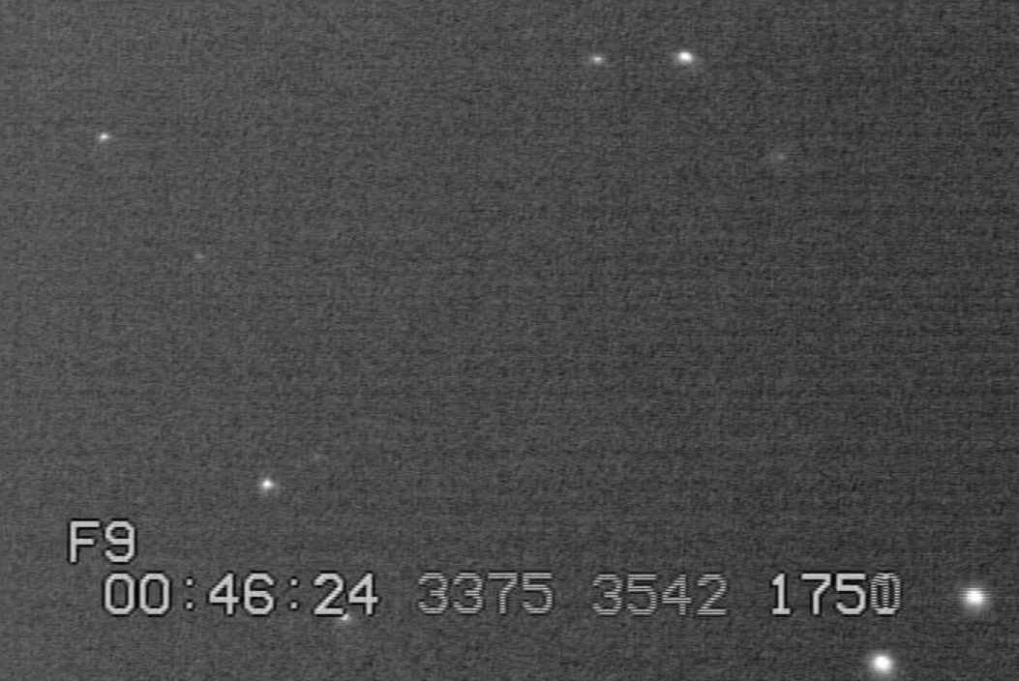

Figure 12: This used the Knight Owl (or Hunter Wu) focal reducer and the Alan Smiley “12.7 mm” adapter, and NO 5mm spacer. The 85 – theta1 Tauri “C” distance was 109 mm, so the focal reduction is 0.51. The video file is 20170403Hyades4.avi:
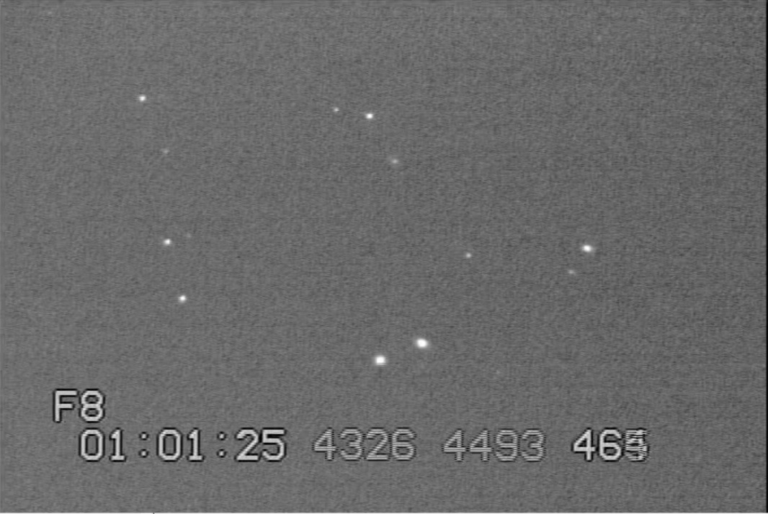

Figure 13: This used the Knight Owl (or Hunter Wu) focal reducer and the Alan Smiley “12.7 mm” adapter, and one 5mm spacer. The “C” distance was 93.3 mm, so the focal reduction is 0.43; this should be equivalent to Fig. 6 (“standard” focal reduction system) where the focal reduction was 0.41, close to this. The video file is 20170403Hyades2.avi :
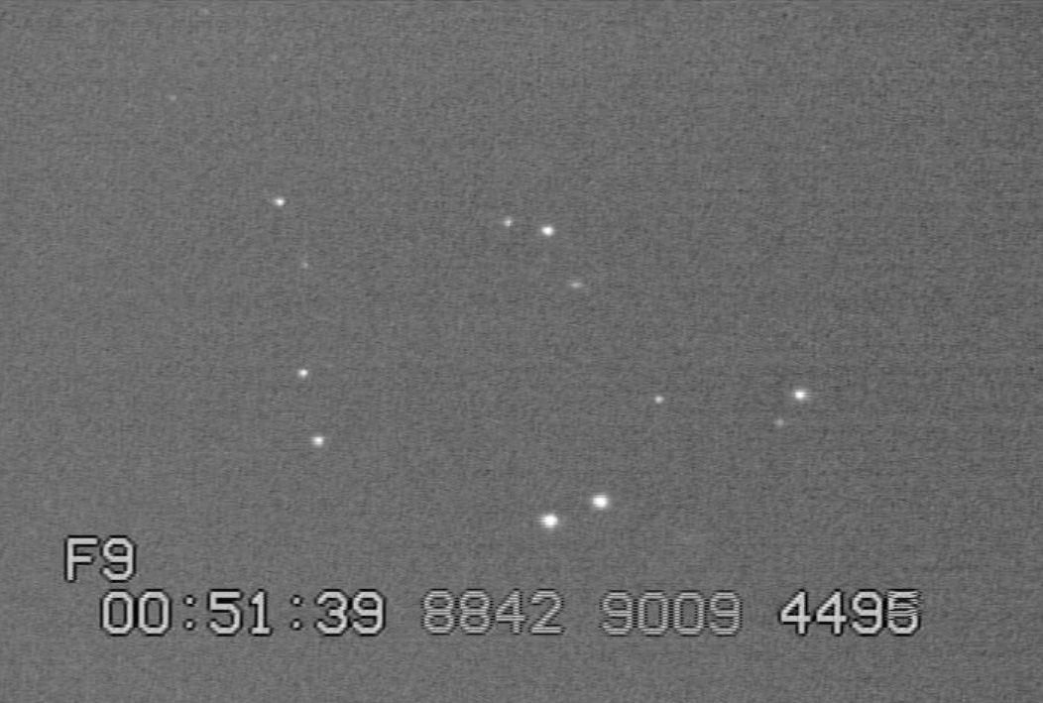

Figure 14: This used the Knight Owl (or Hunter Wu) focal reducer and the Alan Smiley “12.7 mm” adapter, and two 5mm spacers. The “C” distance was 78 mm, so the focal reduction is 0.36, the best of any of the combinations tried. The video file is 20170403Hyades3.avi :
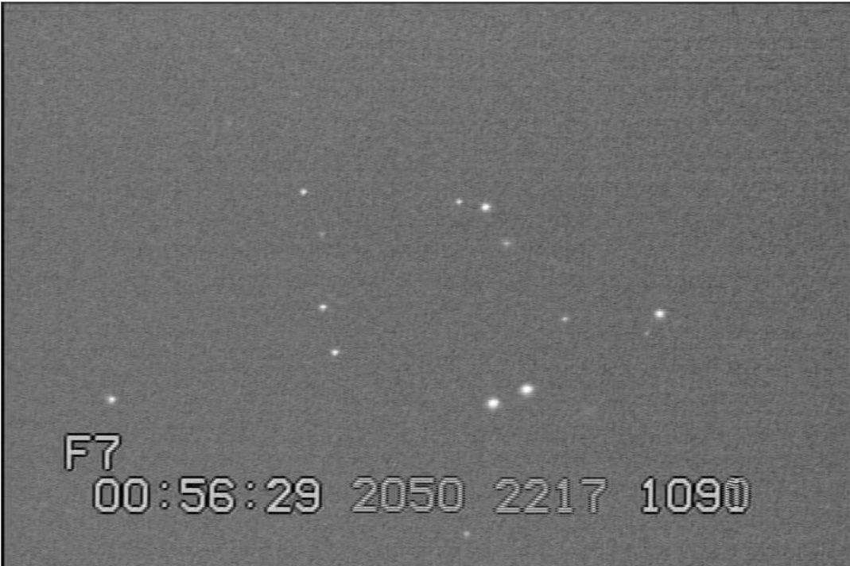

Figure 15: This used the Knight Owl (or Hunter Wu) focal reducer and the Hunter Wu “10 mm” short adapter, and NO 5mm spacer. The 85 – theta1 Tauri “C” distance was 113 mm, so the focal reduction is 0.53. The video file is 20170403Hyades5.avi:
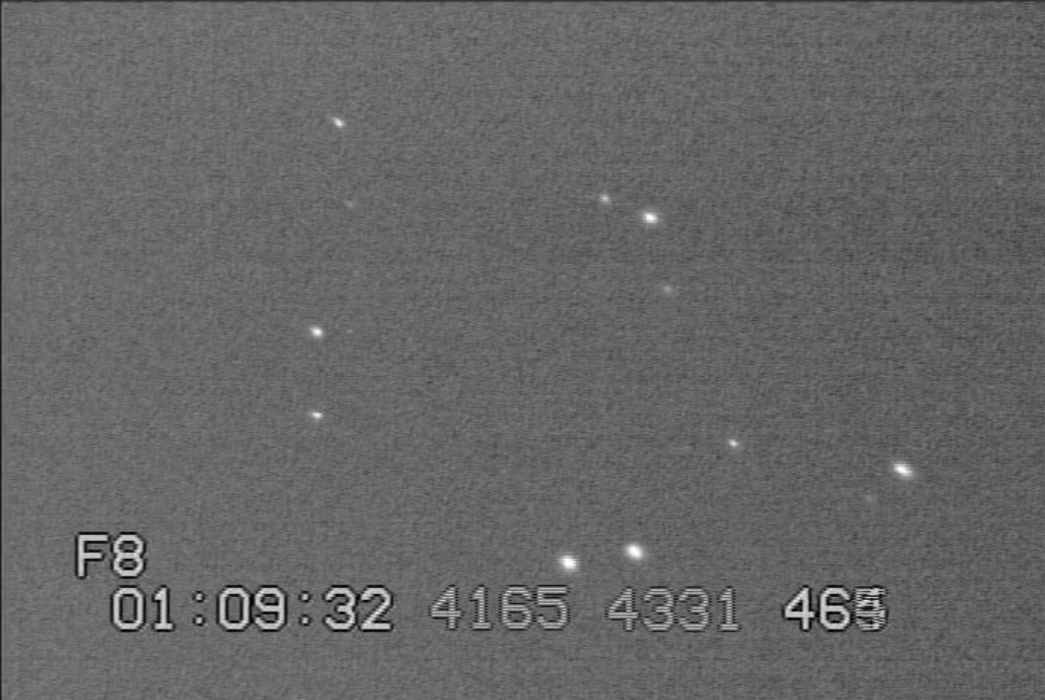

Figure 16: This used the Knight Owl (or Hunter Wu) focal reducer and the Hunter Wu “10 mm” short adapter, and one 5mm spacer. The 85 – theta1 Tauri “C” distance was 99 mm, so the focal reduction is 0.46. The video file is 20170403Hyades6.avi:
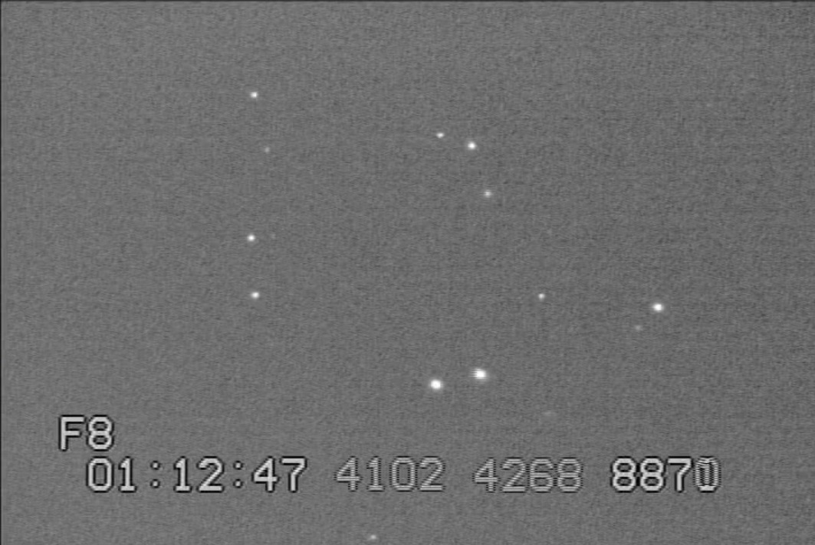
Figure 17: This used the Knight Owl (or Hunter Wu) focal reducer and the Hunter Wu “10 mm” short adapter, and two 5mm spacers. The 85 – theta1 Tauri “C” distance was 85 mm, so the focal reduction is 0.40. The video file is 20170403Hyades7.avi:
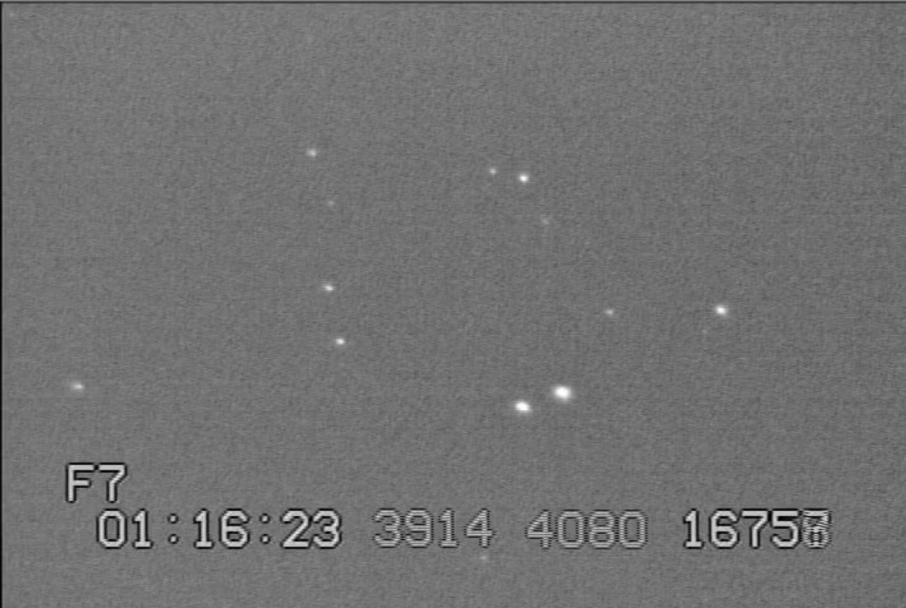
Earlier that night, the 41% waxing Moon occulted 6.6-mag. ZC 943 at CA 68N. I video recorded it with the RunCam Night Eagle camera with no focal reduction with a 10-inch “suitcase” prime focus reflector; it was my first RunCam recording of a lunar occultation (On Jan. 31, we used a RunCam Night Eagle to record the Hersilia asteroidal occultation, the first occultation of any type recorded with that camera). The three pictures below show the frame before the disappearance, one with the star at about 1/4th intensity, and the last, the next frame, with no sign of the star.
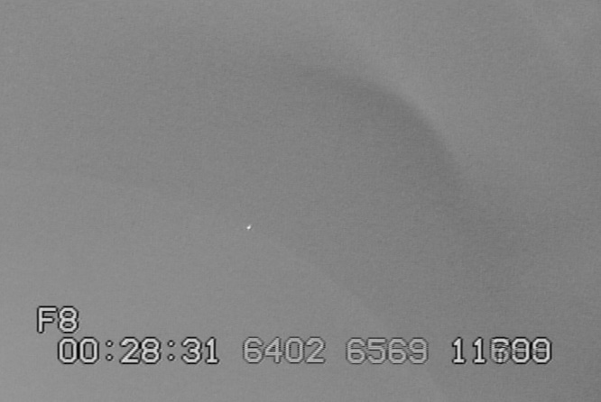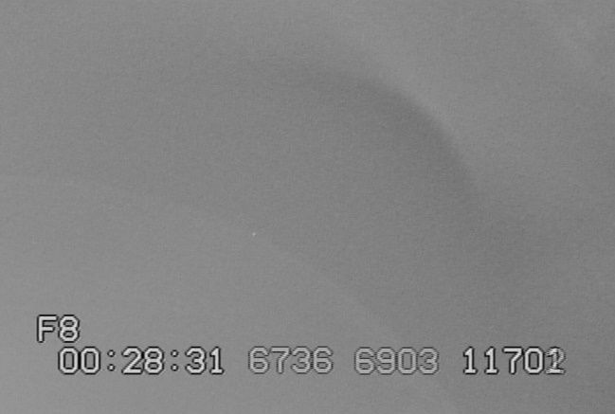
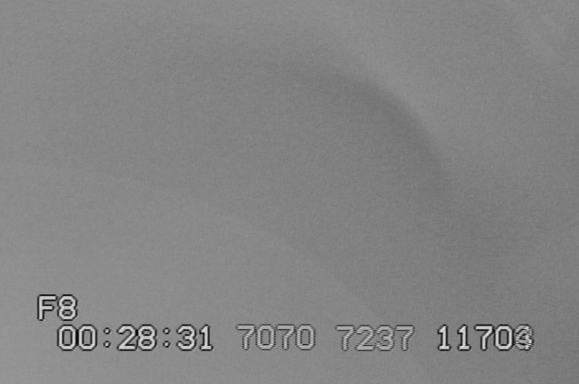 There’s glare, but the dark limb is faintly visible.
Conclusions:
Comparing Figures 1 and 5, and Figures 2 and 6, show that the Supercircuits PC164C-EX2 and RunCam Night Eagle have similar sensitivity, but with the Night Eagle having 4/3rds the scale, and about 1.75 times the area, of the PC164C-EX2, it has a significant advantage (wider field of view) relative to the Knight Owl focal reducer. Without focal reduction, the Night Eagle has 6/5th the scale, and 1.44 times the area, of the PC164C-EX2. Thus, I agree with Tony George’s conclu-sions, that the RunCam Night Eagle is a good replacement (for our small multi-station deployment systems) for the no-longer-available PC164C-EX2, and doesn’t have the hot pixels (so far) that have been a problem with the EX2’s. My impression is that the RunCam background is brighter (I didn’t make any on-screen adjustments) than the EX2’s, more so with my recordings than with Tony’s images, but that might be due to my DC-area skies being more light-polluted than Tony’s in Arizona (and also a lower altitude for my observations). Note that an “Astro” version of the Night Eagle RunCam camera, that will include some integration capability, is under development and should become available soon.
The RunCam cameras are much smaller than the PC164C-EX2’s, making them easier to transport, but unlike the PC164C-EX2’s, they don’t have a camera tripod adapter, so they can’t be used with small camera tripods to form mighty mini’s in the same way (but both Steve Preston and Scotty point out that a hole can be made on the PVC housing, allowing use with the small photographic tripods, and Ted Blank has pictures of how he implemented this). The M12 adapter allows use with all of the systems, including 80mm midi’s (tested here), the very similar 120mm maxi’s, and the 10-in. “suitcase” telescopes. It should also be possible to use the RunCam Night Eagle with a “mighty mini” finder for the suitcase telescopes, since they don’t use the photographic tripod adapter, only the front-end focal reducer connection that the M12 adapter allows. So when I get a chance, I’ll test that; with the wider FOV, the RunCam Night Eagle should have an advantage for a video finder over the EX2.
The April 3rd tests showed that the Hunter Wu “10mm” short C-mount adapter is nearly as good as the “12.7mm” Alan Smiley adapter, adequate for replacing the Alan Smiley adapter, if it becomes unavailable. The tests also showed that adding 5mm spacers increased the focal reduction, so that’s useful to do, the more, the better. Using two 5mm spacers resulted in the shortest focal distance, and the best focal reduction, with the 80mm “midi” system, but trying three 5mm spacers did not work since the focal distance was less than the telescope focus draw tube allowed (so focus could not be achieved).
Equipment Web sites
Cameras:
The Supercircuits PC164C-EX2 is no longer available, although some can occasionally be found on eBay or Astromart.
The RunCam Night Eagle is available for $79.99 from http://shop.runcam.com/runcam-night-eagle/ ask for the Astro version, which has up to 16x integration; Tony George says it’s now available. A separate M12-Cmount adapter is needed, available for $8.99 from http://www.ebay.com/itm/like/111696334929?lpid=82&chn=ps&ul_noapp=true
These items are shipped directly from China; I find that they take almost 3 weeks to arrive, after an order is placed. Expedited shipping (7 – 9 days) is available for the RunCam, but I haven’t seen that option for the M12 adapter (but if you ask, it may be available). The M12-Cmount adapter then mates to a normal 1-1/4-Cmount adapter which can be purchased on Amazon: Solomark C-mount to 1.25'' Adapter Ring - 1.25 Inch Barrel Adapter for Telescope Camcorder and Video Camera but it can also be used to mate to a 0.5 focal reducer and adapter, as specified in the next section.

The Watec 910HX/RC (remote controller version, recommended) is available for $610 for IOTA observers from Darlene Theriault, darlene@avsupply.com or phone 858-565-1101 at www.avsupply.com (AudioVisualSupply) in San Diego, Calif.; when you contact her, say that you are with “Derek Breit’s IOTA group”.

The Mallincam RECON 828 costs $700 from the US Mallincam distributer, Jack’s Astro Accessories LLC in Louisiana, mallincamusa@gmail.com . Info. about the camera is at http://www.mallincamusa.com/Updates%20-%20July%202005/RECON.htm (the RECON 828 is twice as sensitive as the RECON 428, well worth the $100 extra) and the recommended settings can be found at http://tnorecon.net/participant-resources/equipment/camera/ .

“0.5” focal reducers and adapters:
We used to obtain the focal reducing lenses (part D in http://www.asteroidoccultation.com/observations/NA/CameraAttachments.JPG) from Knight Owl http://www.owlastronomy.com/ in Pennsylvania, but they’ve been unresponsive during the past couple of years, so we recommend now to obtain them directly from hunter20099 (Hunter Wu), email hunterwzh@hotmail.com in China. The focal reducer can be purchased for $25.99, from
http://www.ebay.com/itm/New-Multi-Coated-1-25-0-5x-Focal-Reducer-Telescope-Eyepiece-Cnscope-/221987143219?hash=item33af76fe33 . The lens may be reversed and then needs to be flipped; see comment under Fig. 4. Normally, Hunter Wu sells the focal reducer along with a 1.25” adapter for $29.99 from http://www.ebay.com/itm/New-Telescope-1-25-C-Mount-Adapter-w-0-5X-Focal-Reducer-to-CCD-Camera-/221638060863 but we recommend getting different adapters. Scotty Degenhardt found the best spacing to use with these focal reducing lenses is 12.7 mm, and Knight Owl had some of these C-mount adapters (C) made with that spacing, and used to sell them with their focal reducers. Since we can’t get them from Knight Owl any more, some are available for $10 plus shipping from Alan Smiley (in USA), al.smiley@gmail.com . Alan doesn’t sell them from his eBay site. When he runs out, I have some extra that I bought from him in a batch order. These “12.7mm” “Smiley” adapters have a 11mm smooth barrel length, and a total length of 16mm. These 12.7mm adapters also need to be used with a 5mm C-mount spacer (B; or better, 2 of them, as the April 3rd tests showed) available from different sources; one is http://www.ebay.com/itm/like/172401253504?lpid=82&chn=ps&ul_noapp=true in New York, 5 of them for $15.45. Hunter Wu sells a shorter C-mount adapter, he calls it the Short C Mount to 1.25" Barrel Adapter f/ Telescope Astrophotography 10mm Height Item# 222374198200 available at http://www.ebay.com/itm/Short-C-Mount-to-1-25-034-Barrel-Adapter-f-Telescope-Astrophotography-10mm-Height-/222374198200?rsta=en_US(en_US)&cnac=US&mail=sys&e=op&unp_tpcid=email-receipt-auction-payment&ppid=PPX000608&calf=80c42ea41e272&calc=80c42ea41e272&pgrp=main:email&unptid=0a2c95ce-0ba3-11e7-9799-441ea1477c68&mchn=em&t=&s=ci&page=main:email&cal=80c42ea41e272&cust= . The smooth part of the Hunter Wu adapter is 7mm long, while the total length is 13mm. The last part of this document above discusses the differences between this adapter, and the “12.7 mm” adapter sold by Alan Smiley.

In late January 2017, I ordered a 0.5 focal reducer and adapter from Mallincam, specifically, from the Mallincam US distributer, Jack's Astro Accessories at mallincamusa@gmail.com . I purchased it with a Mallincam camera; the cost of the focal reducer and adapter was $49.99, with shipping and handling extra. The smooth length of the Mallincam focal reducer is 22mm and the total length is 28mm. But as noted above, the best focal reduction with the Mallincam combination was found to be 0.58, while a significantly better reduction of 0.47 (or even 0.36 with 2 5mm spacers) can be achieved with the “Knight Owl” (Hunter Wu) focal reducer, the short Smiley (or Hunter Wu) adapter, and 5mm spacer(s) noted above.

David Dunham, 2017 April 4

