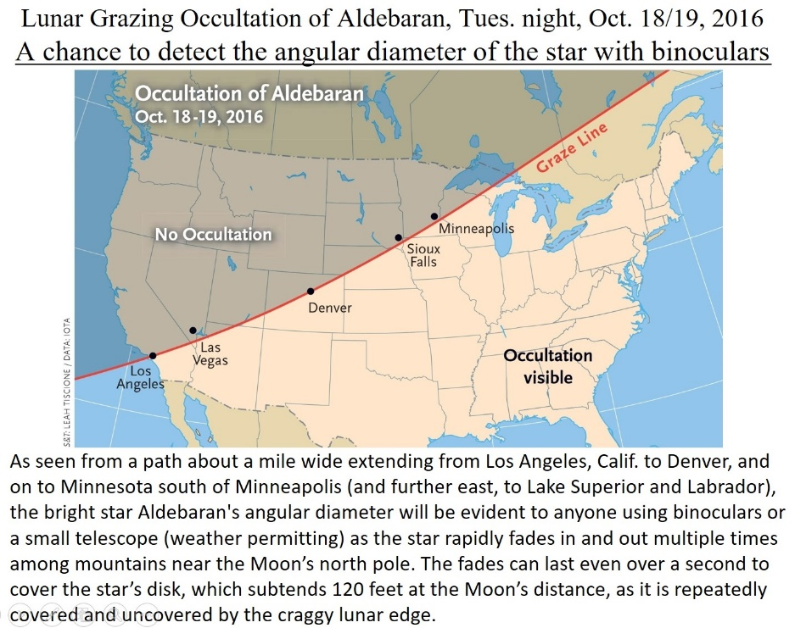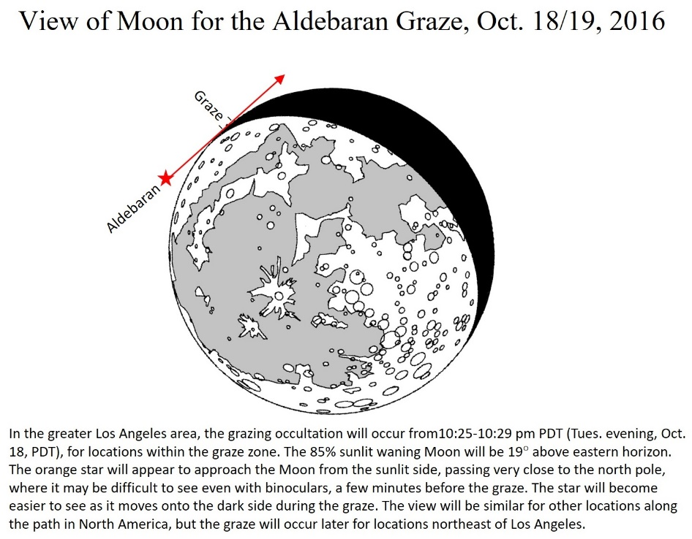
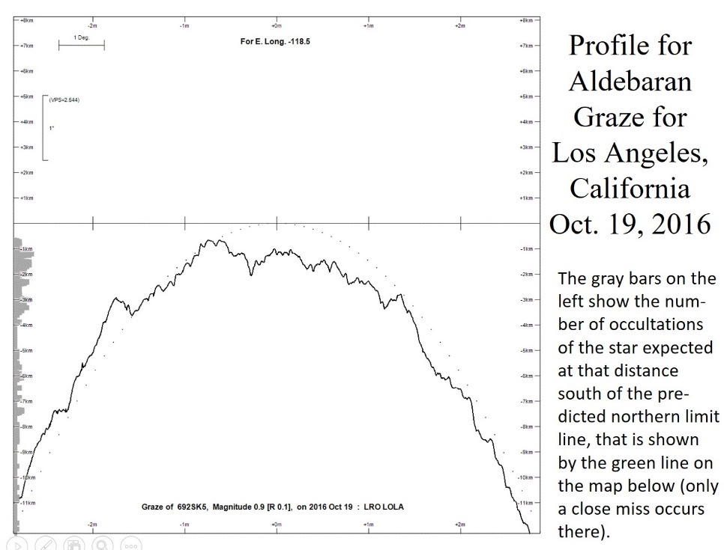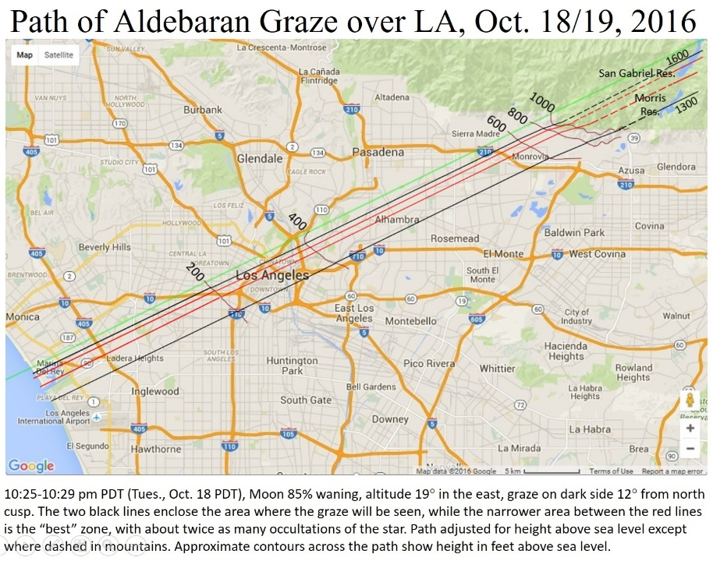
Several Maps, Interactive Google Maps, and other event details are at www.occultations.org/Aldebaran/2016October while a press release about the event from the International Occultation Timing Association is at
http://www.asteroidoccultation.com/observations/NA/Aldebaran/Public.htm . Clear skies are forecast and we plan to observe the graze probably from sites on the e. side of Hwy 39 w. of the San Gabriel Reservoir; we are seeking observers with tracking telescopes to join the effort; we want to attach video cameras (one color) that fit into standard 1.25” eyepiece holders. David Dunham, International Occultation Timing Association, dunham@starpower.net , cell 301-526-5590,

